Summary so far….

Classifying Matter
Match each of the following examples to the relevant diagram:

HCl + SiO₂ CaO CO₂ + MgO H₂O + F₂
FeCl₂ N₂ Ne Ar + O₂
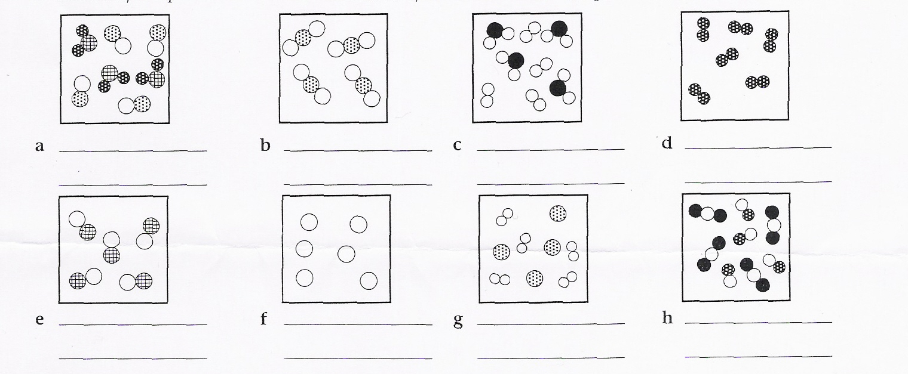

Periodic Table
Use the substances in the box to answer the following questions:
diamond (C) P₄ Li Cl₂ I₂ Ca K Ne Hg Be N₂

- Which substances are the best electrical conductors?
- Which substances are non-metals?
- Which is the most reactive metal?
- Which is the lightest Group 1 substance?
- Which substance produces +2 ions?
- Which substance has the lowest A?
- Which substance is unreactive?
- Which substance is the most abundant in the atmosphere?
- Which substances are used as disinfectants because of their powerful oxidising strength?
- Which substances are gases at STP?
- Which substances have 5 valence electrons?
- The substances in (a) above can be divided into two groups based on what physical property?

Atomic Structure
- What is the relationship between the electron configuration of an atom of an element and the position of that element on the Periodic Table?
- Complete the table:

Symbol | Element | Atomic number | Mass number | No. of protons | No. of neutrons | No. of electrons | Electron configuration
H | hydrogen | 1 | 3 | 1 | 2 | 1 | 1
O |  |  |  |  | 10 | 8
 | magnesium |  |  |  | 12
 |  | 7 | 14
Na |  |  | 23
 |  |  |  |  | 14 | 13
 |  | 19 | 40
S |  |  |  |  | 16
 |  |  |  | 4 | 5
 |  |  | 19 | 9

